„დანართი №3


INCLUDEPICTURE "https://matsne.gov.ge/document-image/documentImage?img=/3/276/255_files/image002.png" \* MERGEFORMATINET INCLUDEPICTURE "https://matsne.gov.ge/document-image/documentImage?img=/3/276/255_files/image002.png" \* MERGEFORMATINET INCLUDEPICTURE "https://matsne.gov.ge/document-image/documentImage?img=/3/276/255_files/image002.png" \* MERGEFORMATINET INCLUDEPICTURE "https://matsne.gov.ge/document-image/documentImage?img=/3/276/255_files/image002.png" \* MERGEFORMATINET INCLUDEPICTURE "https://matsne.gov.ge/document-image/documentImage?img=/3/276/255_files/image002.png" \* MERGEFORMATINET INCLUDEPICTURE "https://matsne.gov.ge/document-image/documentImage?img=/3/276/255_files/image002.png" \* MERGEFORMATINET INCLUDEPICTURE "https://matsne.gov.ge/document-image/documentImage?img=/3/276/255_files/image002.png" \* MERGEFORMATINET INCLUDEPICTURE "https://matsne.gov.ge/document-image/documentImage?img=/3/276/255_files/image002.png" \* MERGEFORMATINET INCLUDEPICTURE "https://matsne.gov.ge/document-image/documentImage?img=/3/276/255_files/image002.png" \* MERGEFORMATINET INCLUDEPICTURE "https://matsne.gov.ge/document-image/documentImage?img=/3/276/255_files/image002.png" \* MERGEFORMATINET 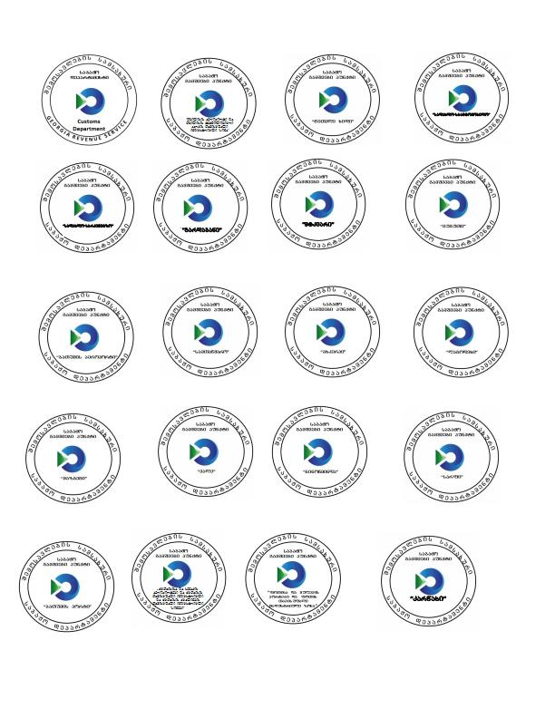

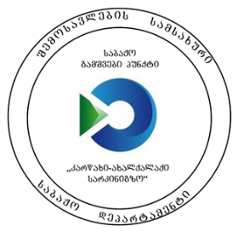


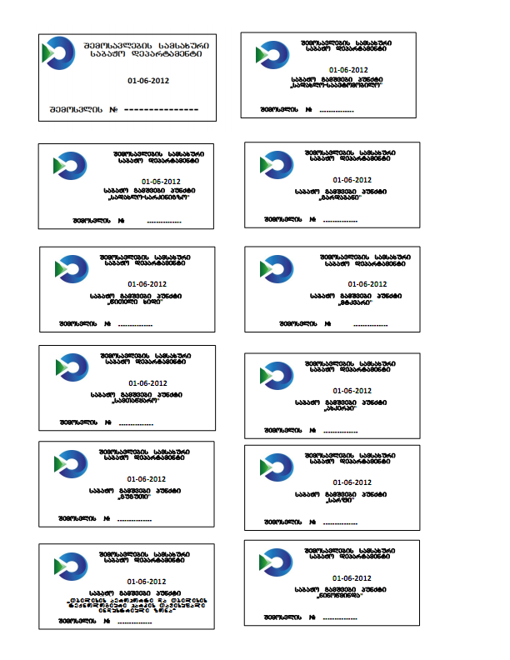 INCLUDEPICTURE "https://matsne.gov.ge/document-image/documentImage?img=/3/276/255_files/image005.png" \* MERGEFORMATINET INCLUDEPICTURE "https://matsne.gov.ge/document-image/documentImage?img=/3/276/255_files/image005.png" \* MERGEFORMATINET INCLUDEPICTURE "https://matsne.gov.ge/document-image/documentImage?img=/3/276/255_files/image005.png" \* MERGEFORMATINET INCLUDEPICTURE "https://matsne.gov.ge/document-image/documentImage?img=/3/276/255_files/image005.png" \* MERGEFORMATINET INCLUDEPICTURE "https://matsne.gov.ge/document-image/documentImage?img=/3/276/255_files/image005.png" \* MERGEFORMATINET INCLUDEPICTURE "https://matsne.gov.ge/document-image/documentImage?img=/3/276/255_files/image005.png" \* MERGEFORMATINET INCLUDEPICTURE "https://matsne.gov.ge/document-image/documentImage?img=/3/276/255_files/image005.png" \* MERGEFORMATINET INCLUDEPICTURE "https://matsne.gov.ge/document-image/documentImage?img=/3/276/255_files/image005.png" \* MERGEFORMATINET INCLUDEPICTURE "https://matsne.gov.ge/document-image/documentImage?img=/3/276/255_files/image005.png" \* MERGEFORMATINET INCLUDEPICTURE "https://matsne.gov.ge/document-image/documentImage?img=/3/276/255_files/image005.png" \* MERGEFORMATINET 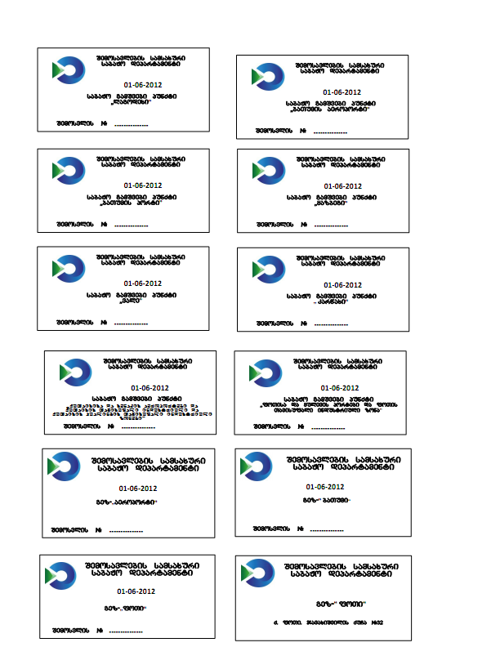
INCLUDEPICTURE "https://matsne.gov.ge/document-image/documentImage?img=/3/276/255_files/image006.png" \* MERGEFORMATINET INCLUDEPICTURE "https://matsne.gov.ge/document-image/documentImage?img=/3/276/255_files/image006.png" \* MERGEFORMATINET INCLUDEPICTURE "https://matsne.gov.ge/document-image/documentImage?img=/3/276/255_files/image006.png" \* MERGEFORMATINET INCLUDEPICTURE "https://matsne.gov.ge/document-image/documentImage?img=/3/276/255_files/image006.png" \* MERGEFORMATINET INCLUDEPICTURE "https://matsne.gov.ge/document-image/documentImage?img=/3/276/255_files/image006.png" \* MERGEFORMATINET INCLUDEPICTURE "https://matsne.gov.ge/document-image/documentImage?img=/3/276/255_files/image006.png" \* MERGEFORMATINET INCLUDEPICTURE "https://matsne.gov.ge/document-image/documentImage?img=/3/276/255_files/image006.png" \* MERGEFORMATINET INCLUDEPICTURE "https://matsne.gov.ge/document-image/documentImage?img=/3/276/255_files/image006.png" \* MERGEFORMATINET INCLUDEPICTURE "https://matsne.gov.ge/document-image/documentImage?img=/3/276/255_files/image006.png" \* MERGEFORMATINET INCLUDEPICTURE "https://matsne.gov.ge/document-image/documentImage?img=/3/276/255_files/image006.png" \* MERGEFORMATINET 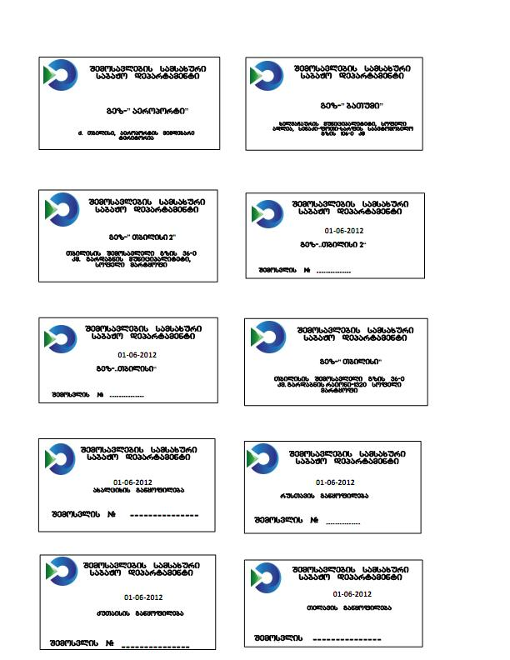
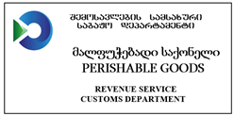
INCLUDEPICTURE "https://matsne.gov.ge/document-image/documentImage?img=/3/276/255_files/image007.png" \* MERGEFORMATINET INCLUDEPICTURE "https://matsne.gov.ge/document-image/documentImage?img=/3/276/255_files/image007.png" \* MERGEFORMATINET INCLUDEPICTURE "https://matsne.gov.ge/document-image/documentImage?img=/3/276/255_files/image007.png" \* MERGEFORMATINET INCLUDEPICTURE "https://matsne.gov.ge/document-image/documentImage?img=/3/276/255_files/image007.png" \* MERGEFORMATINET INCLUDEPICTURE "https://matsne.gov.ge/document-image/documentImage?img=/3/276/255_files/image007.png" \* MERGEFORMATINET INCLUDEPICTURE "https://matsne.gov.ge/document-image/documentImage?img=/3/276/255_files/image007.png" \* MERGEFORMATINET INCLUDEPICTURE "https://matsne.gov.ge/document-image/documentImage?img=/3/276/255_files/image007.png" \* MERGEFORMATINET INCLUDEPICTURE "https://matsne.gov.ge/document-image/documentImage?img=/3/276/255_files/image007.png" \* MERGEFORMATINET INCLUDEPICTURE "https://matsne.gov.ge/document-image/documentImage?img=/3/276/255_files/image007.png" \* MERGEFORMATINET INCLUDEPICTURE "https://matsne.gov.ge/document-image/documentImage?img=/3/276/255_files/image007.png" \* MERGEFORMATINET 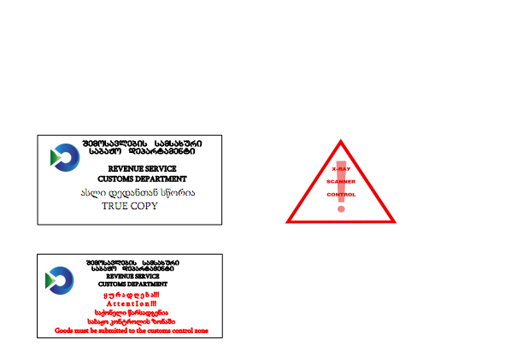
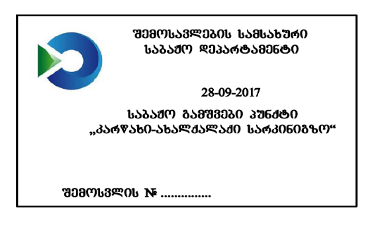
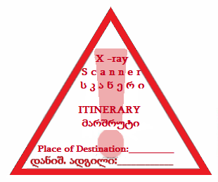
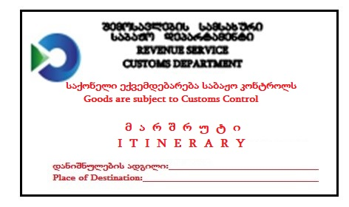

GEORGIA REVENUE SERVICE
CUSTOMS DEPARTMENT
შემოსავლების სამსახური
საბაჟო დეპარტამენტი

NCTS FALLBACK PROCEDURE
NCTS-ის სათადარიგო პროცედურა

UNION TRANSIT/COMMON TRANSIT
კავშირის ტრანზიტი/საერთო ტრანზიტი

NO DATA AVAILABLE IN THE SYSTEM
სისტემაში მონაცემები მიუწვდომელია
მიღებულია: __________
(თარიღი/საათი)

GEORGIA REVENUE SERVICE
CUSTOMS DEPARTMENT
შემოსავლების სამსახური
საბაჟო დეპარტამენტი

BUSINESS CONTINUITY PROCEDURE
ბიზნესის უწყვეტობის პროცედურა

UNION TRANSIT/COMMON TRANSIT
კავშირის ტრანზიტი/საერთო ტრანზიტი

NO DATA AVAILABLE IN THE SYSTEM
სისტემაში მონაცემები მიუწვდომელია
მიღებულია: __________
(თარიღი/საათი)

“

