Annex
Flag of the President of Georgia

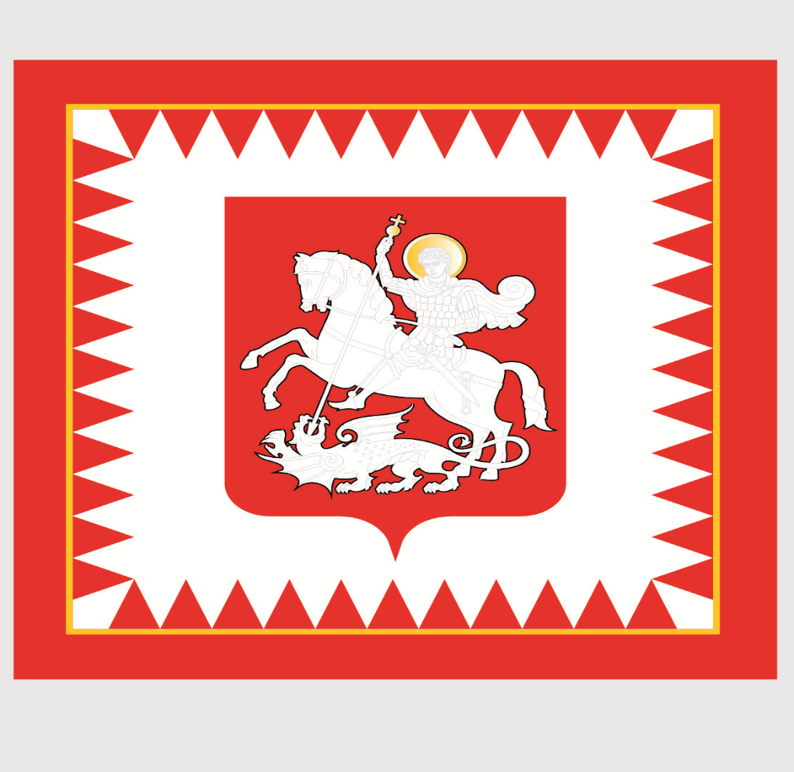

The flag of the President of Georgia is a white square flag. In the centre of the flag a shield of a small coat of arms of Georgia is placed, on the purple field of which is depicted an image of Saint George, a silver rider with a golden halo, impailing a silver dragon with a silver lance ending with a golden cross. The flag of the President of Georgia is banded with a red outline with red jags from the inside.

