Procedure for Hoisting, Displaying and Depicting Symbols of State Significance together with the State Symbols of Georgia
Procedure for hoisting and displaying a symbol of state significance (flag) together with the state flag of Georgia
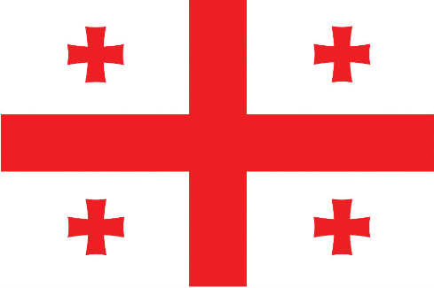
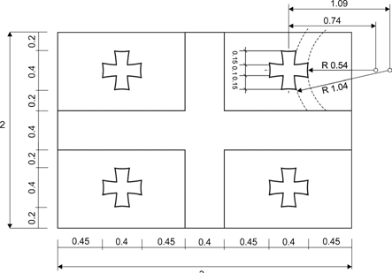

- The state flag of Georgia shall be given priority and a place of honour in the territory of Georgia in relation to a symbol of state significance (flag), as well as to all other flags.
- The state flag of Georgia shall be hoisted together with a symbol of state significance (flag) and displayed only in a place of honour.
- The state flag of Georgia and a symbol of state significance (flag) shall be lit or hoisted only during the daylight, in the open air, and in places of permanent hoisting and displaying.
- The state flag of Georgia, when hoisted together with a symbol of the state significance (flag), shall be unfurled and shall not touch the ground, water or wall while flying.
- During a state event, the state flag of Georgia and a symbol of state significance (flag) shall be brought into a building in a hoisted position.
- During a state event, the state flag of Georgia and a symbol of state significance (flag) shall be hoisted and lowered to the accompaniment of the national anthem of Georgia.
- The state flag of Georgia, the flag of a foreign state, that of an international organisation, and symbols of state significance (flags) and other flags, shall be hoisted and displayed in the places assigned to them, on a handle or a flagpole of the same length, at the same height.
- When hoisting or displaying a flag of a foreign state, an international organisation or other flags and symbols of state significance (flags) in a row, in a circular or semicircular position, along with the state flag of Georgia, the state flag of Georgia shall be hoisted or displayed to the left of the right of the representative according to the Georgian names of states, international organisations and other flags and state symbols (flags) of Georgia, in alphabetical order in Georgian (or Abkhazian in the territory of the Autonomous Republic of Abkhazia), the state language of Georgia.
- When hoisting or displaying the state flag of Georgia and symbols of state significance (flags), the attendee shall stand facing the flags.
It is inadmissible to:
- misuse a symbol of state significance (flag);
- decorate a symbol of state significance (flag) with any image, or cover it with drawings;
- damage a symbol of state significance (flag);
- preserve a symbol of state significance (flag) in conditions dangerous or unsuitable therefor;
- profane a symbol of state significance (flag) by hoisting and displaying it in an inappropriate manner in relation to another flag according to the procedure.

Sequence of hoisting and displaying flags in the territory of Georgia according to significance
  - the state flag of Georgia;
  - the state or national flag of another country;
  - the flag of an international organisation;
  - the flag of an Autonomous Republic of Georgia;
  - a municipal flag of Georgia;
  - the flag of a public institution of Georgia;
  - the flag of a public association/organisation;
  - other flag.

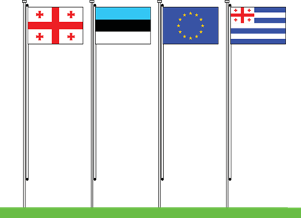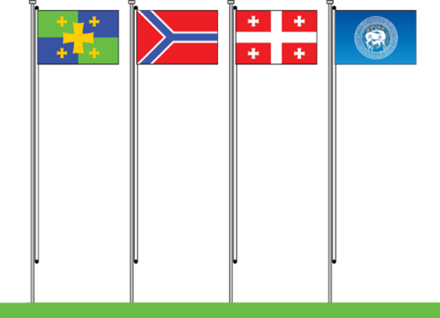

Procedure for hoisting and displaying the state flag of Georgia together with a symbol of state significance (flag)

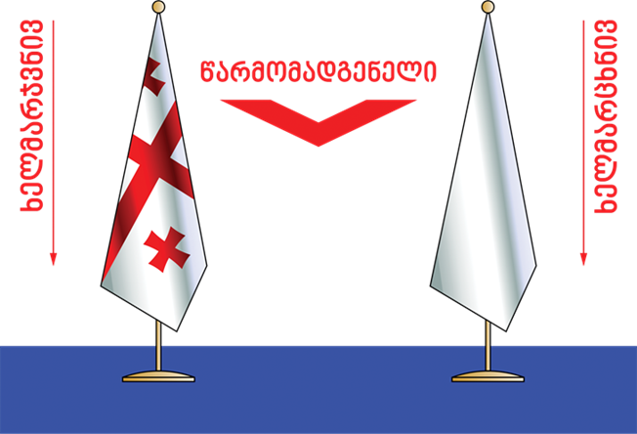
REPRESENTATIVE
On the Right
On the Left

ATTENDEE

- A representative of the state (public institution) of Georgia shall hoist and display only the state flag of Georgia in the absence of one of the symbols of state significance (flag).
- When hoisting two flags, the state flag of Georgia and a symbol of state significance (flag), the state flag of Georgia shall be hoisted to the right of a representative of a state (public institution) of Georgia, in a place of honour.

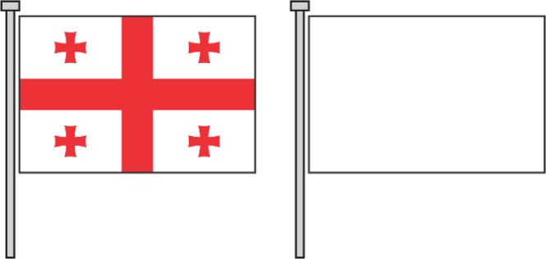

- When hoisting three and five flags, the state flag of Georgia shall be hoisted in the middle and all other flags (of a foreign state, an international organisation), and symbols of state significance (flags), shall be hoisted according to their Georgian names, in alphabetical order in Georgian (or Abkhazian in the territory of the Autonomous Republic of Abkhazia), the state language of Georgia, to the left of the right of the representative.

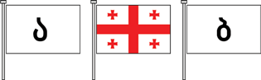
A
B

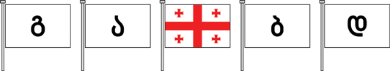
C
A
B
D

- When hoisting four flags, the state flag of Georgia shall be hoisted the second in a row, to the right of the representative and all other flags (of a foreign state, an international organisation), and symbols of state significance (flags) and others, shall be hoisted according to their Georgian names, in alphabetical order in Georgian (or Abkhazian in the territory of the Autonomous Republic of Abkhazia), the state language of Georgia, to the right of the left of the representative.

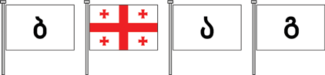
B
A
C

- When hoisting six or more flags, the state flag of Georgia shall be hoisted at the edge, first in a row to the right of the representative and shall take a place of honour, while all other flags (of a foreign state, an international organisation), and symbols of state significance (flags) and others, shall be hoisted according to their Georgian names, in alphabetical order in Georgian (or Abkhazian in the territory of the Autonomous Republic of Abkhazia), the state language of Georgia, to the left of the right of the representative, in a row.

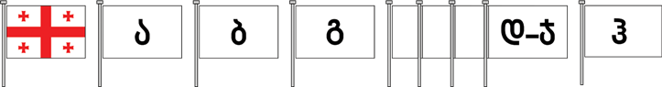
A
D-Y
B
C
Z

- When hoisting flags in a circle, the state flag of Georgia shall be hoisted in the middle of the circle, in a place of honour, and all other flags (of a foreign state, an international organisation), and symbols of state significance (flags) and others, shall be hoisted according to their Georgian names, in alphabetical order in Georgian (or Abkhazian in the territory of the Autonomous Republic of Abkhazia), the state language of Georgia, in a circle, clockwise.
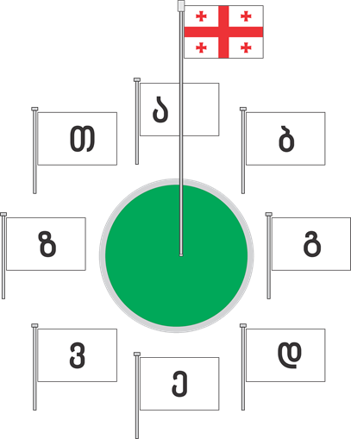
A
B
F
G
H
D
C
E

- When hoisting flags in a semicircle at the entrance of a building, the state flag of Georgia shall be hoisted in front of the main entrance, in the middle place of honour, and all other flags (of a foreign state, an international organisation), and symbols of state significance (flags) and others, shall be hoisted according to their Georgian names, in alphabetical order in Georgian (or Abkhazian in the territory of the Autonomous Republic of Abkhazia), the state language of Georgia, circularly, counter-clockwise on the side of the representative building.

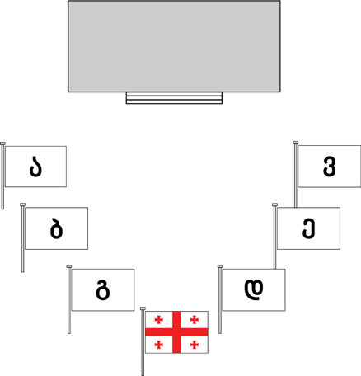
A
B
C
D
E
F

- At the entrance of a building, to the right of a representative institution, when the flags are hoisted in one row along the carriageway, the state flag of Georgia shall be hoisted last in the row; all other flags (of a foreign state, an international organisation), and symbols of state significance (flags) and others, shall be hoisted according to their Georgian names, in alphabetical order in Georgian (or Abkhazian in the territory of the Autonomous Republic of Abkhazia), the state language of Georgia, in the direction of the building from the state flag of Georgia.

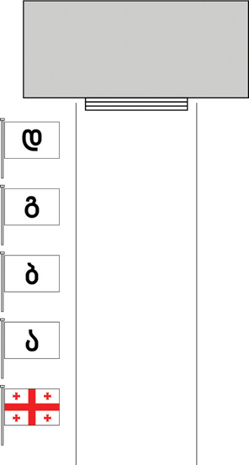
D
C
B
A

- When hoisting flags in two rows at the entrance of a building, along the carriageway, the state flag of Georgia shall be hoisted last in the row, to the right of the representative institution, and all other flags (of a state, an international organisation).
- Symbols of state significance (flags), and others, shall be hoisted according to their Georgian names, in alphabetical order in Georgian, (or Abkhazian in the territory of the Autonomous Republic of Abkhazia), the state language of Georgia, in the direction of the building from the state flag of Georgia in both rows.

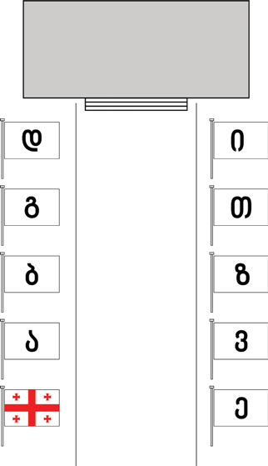
A
D
C
B
I
H
G
F
E

- When hoisting flags in two rows at the entrance of a building, along the carriageway, two state flags of Georgia shall be hoisted last in both rows on the sides of the representative institution, and all other flags (of a foreign state, an international organisation).
- Symbols of state significance (flags), and others, shall be hoisted according to their Georgian name, in alphabetical order in Georgian (or Abkhazian in the territory of the Autonomous Republic of Abkhazia), the state language of Georgia, in the direction of the building from the state flag of Georgia in both rows.

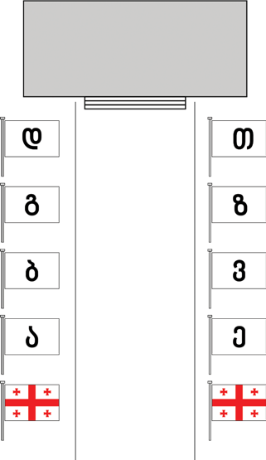
H
G
F
E
D
C
B
A

- When a representative of the state (public institution) of Georgia hoists only one flag, the state flag of Georgia shall be hoisted in front of the building of the institution and on the roof of the building.

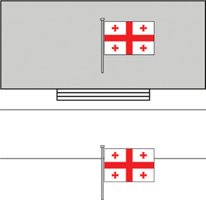

- Regardless of the number of flags and flagpoles at a building of a representative of the state (public institution) of Georgia, the state flag of Georgia and symbols of state significance (flags) shall be hoisted in accordance with the procedures determined above.

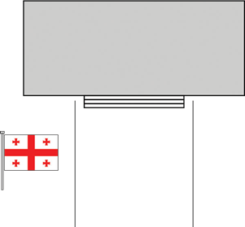

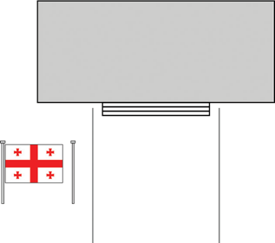
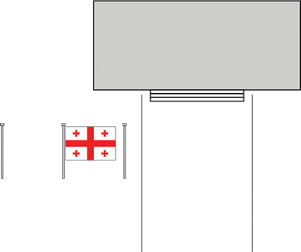

Procedure for hoisting and displaying the state flag of Georgia and symbols of state significance (flags) together with other flags
- When hoisting one flag during a speech of a representative of the state (public institution) of Georgia, only the state flag of Georgia shall be hoisted to the right of the state representative.

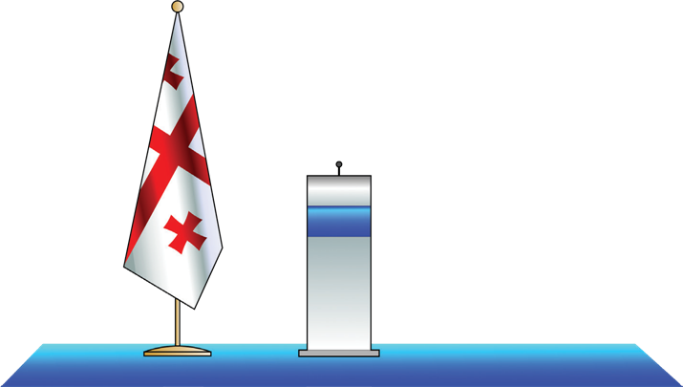

- When a representative of the state (public institution) of Georgia hoists two flags (to the left and to the right), the state flag of Georgia shall be hoisted to the right of the representative in a place of honour and the symbol of state significance (flag) shall be hoisted to the left of the representative.

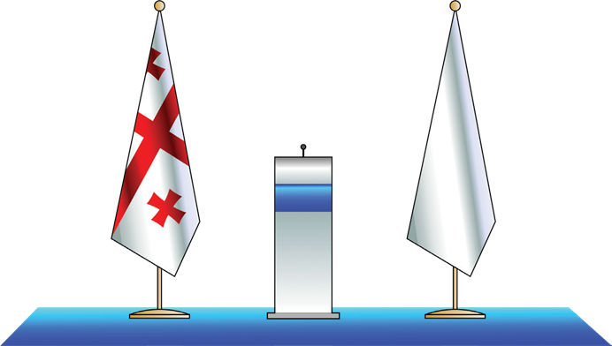

- When hoisting two flags to the right of a representative of the state (public institution) of Georgia, the state flag of Georgia shall be hoisted in a place of honour, first, at the right edge to the representative.

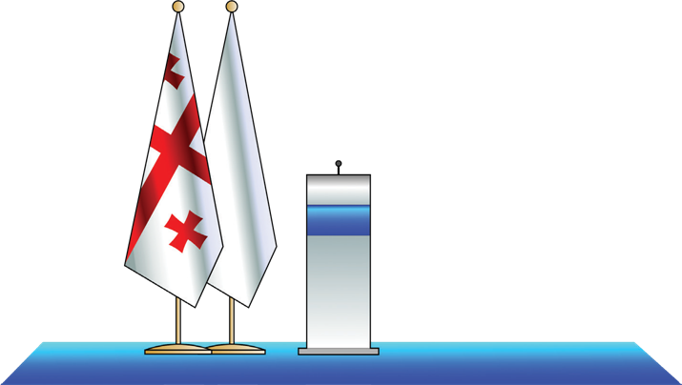

- When hoisting three flags with a representative of the state (public institution) of Georgia, two to the right and one to the left, the state flag of Georgia shall be hoisted in the middle, to the right of the representative.

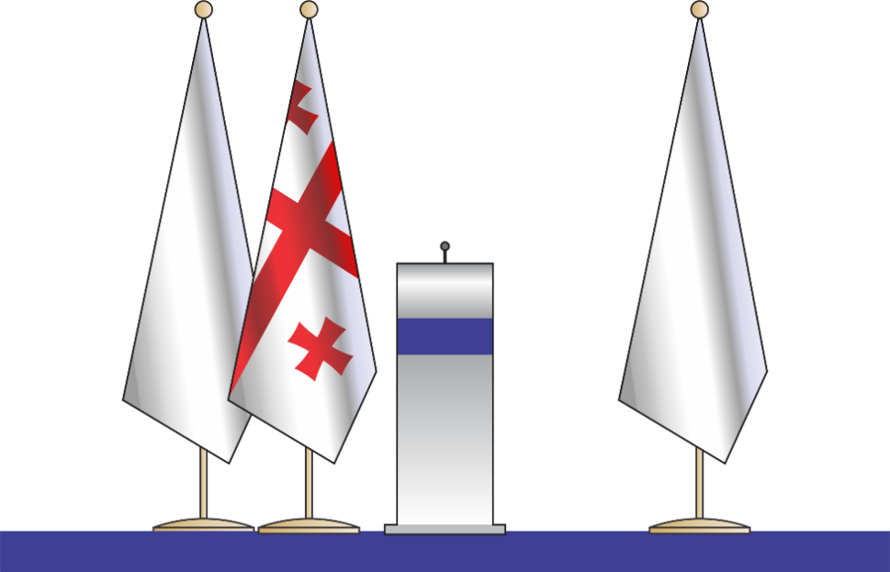

- When hoisting three and five flags together, the state flag of Georgia shall be hoisted in the middle in relation to the other flags (of a foreign state, an international organisation) and symbols of state significance (flags).

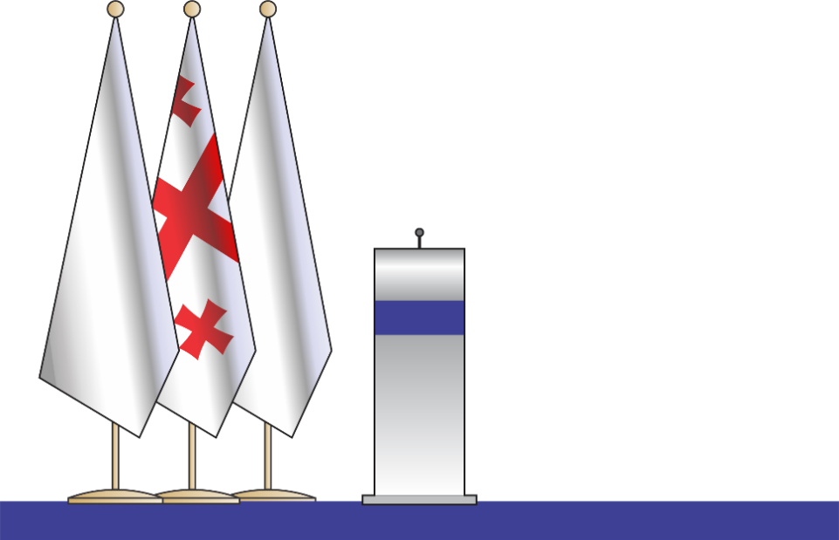

- Two representatives of state (public institution) each represented with the state flag of Georgia and their own symbol of state significance (flag): the representative of the host institution shall give place of honour on the right to the guest. Both representatives shall hoist the state flag of Georgia and the symbol of state significance (flag) of the institution he/she personally represents; in both cases, the state flag of Georgia shall be hoisted to the right, in a place of honour.

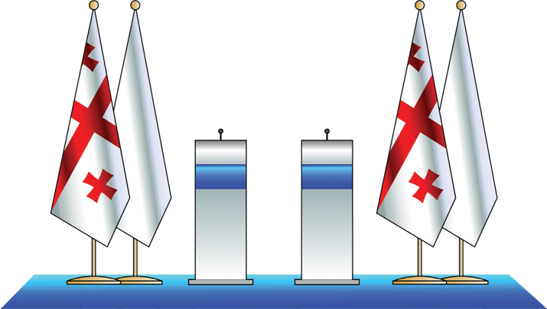

- When two representatives are hoisting three flags, the state flag of Georgia, the flag of another state or international organisation, and a symbol of state significance (flag), each shall hoist all three flags, and in both cases the state flag of Georgia shall be hoisted in the middle, in a place of honour.

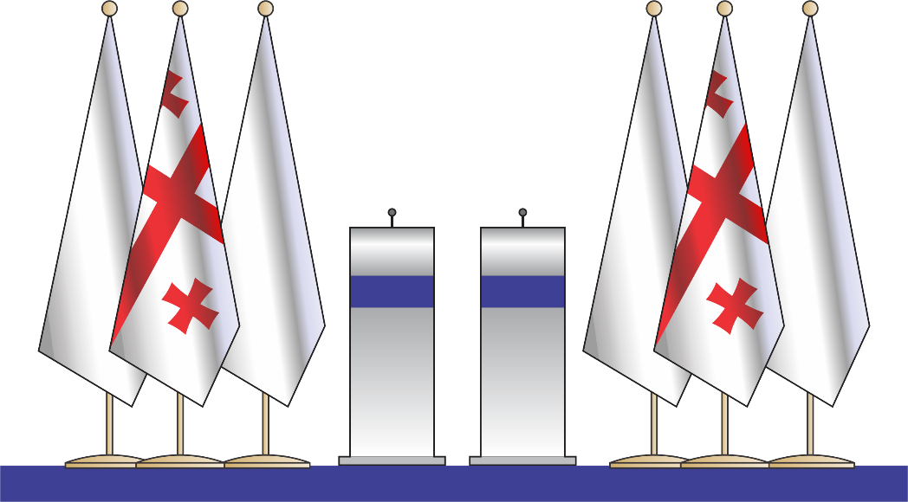

- Three representatives, each with one flag and one common flag: each hoists their own flag and all three hoist one common flag, out of these four flags, the state flag of Georgia shall be hoisted in the second place of honour.

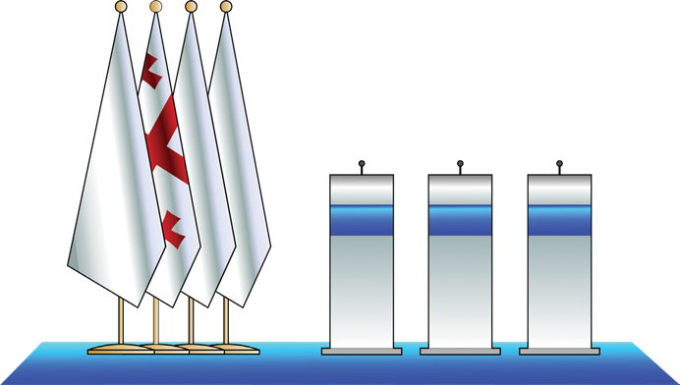

Other occasions of hoisting and displaying the state flag of Georgia together with a symbol of state significance (flag)

- When hoisting two flags at the table of state representatives, the state flag of Georgia shall be hoisted to the right of the representative, in a place of honour.

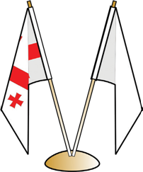

- When hoisting three flags at the table of state representatives, the state flag of Georgia shall be hoisted in the middle place of honour.

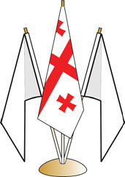

- When representatives of the state (public institutions) meet at round table, if the flags of other states are hoisted in a circle on the table along with the state flag of Georgia, the state flag of Georgia shall be hoisted directly facing the main entrance, in the middle place of honour, or in the middle of the round table, in a place of honour, and all other flags (of a foreign state, an international organisation), and symbols of state significance (flags) and others, shall be hoisted according to their Georgian names, in alphabetical order in Georgian (or Abkhazian in the territory of the Autonomous Republic of Abkhazia), the state language of Georgia, in a clockwise direction.
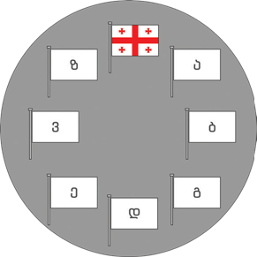
G
A
B
C
D
E
F

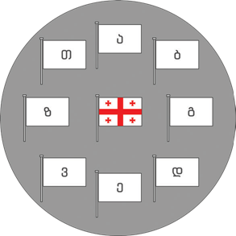
A
H
B
G
C
D
F
E

Military Parades
During marching with hoisted flags:
- When marching in a row along the carriageway, with the state flag of Georgia, other flags (of a foreign state, an international organisation) and symbols of state significance (flags) hoisted, the state flag of Georgia shall be hoisted first in a row.

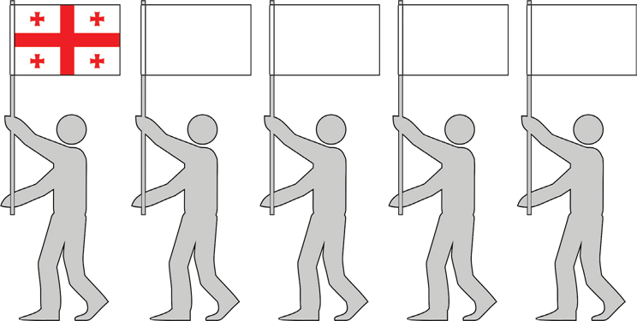

- When marching in a row in a perpendicular direction to the carriageway with the state flag of Georgia and other flags (of a foreign state, an international organisation) and symbols of state significance (flags) hoisted, the state flag of Georgia shall be hoisted at the edge, first in a row to the right of the representative.

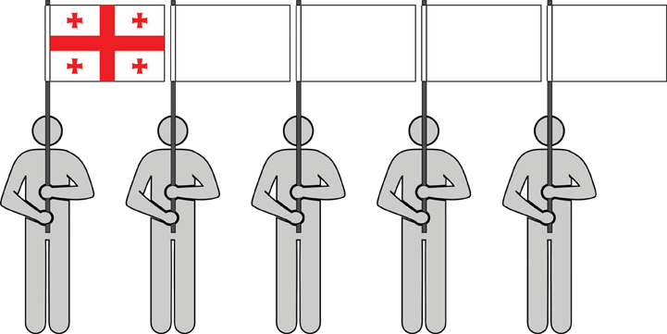

- In other cases, when marching in a row in a perpendicular direction to the carriageway, with the state flag of Georgia, other flags (of a foreign state, an international organisation) and symbols of state significance (flags) hoisted, the state flag of Georgia shall be hoisted at both edges of a row, to the right and to the left of the representative.

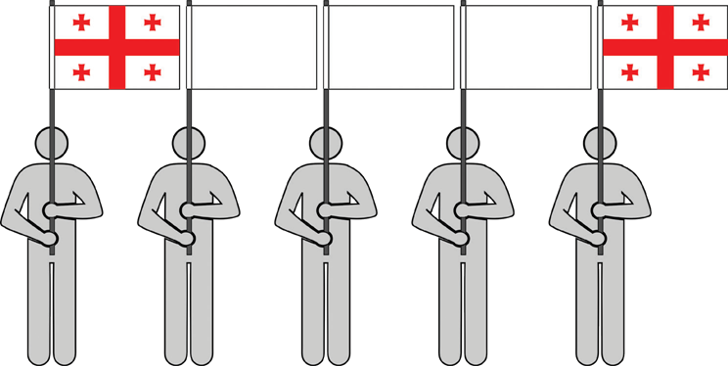

At stadiums
When hoisting flags in a circle during sports events, the state flag of Georgia shall be hoisted directly in front of the main entrance of the sports field, in a place of honour, while all other flags (of a foreign state, an international organisation), and symbols of state significance (flags) and others, shall be hoisted according to their Georgian names, in alphabetical order in Georgian (or Abkhazian in the territory of the Autonomous Republic of Abkhazia), the state language of Georgia, in a circle, clockwise.

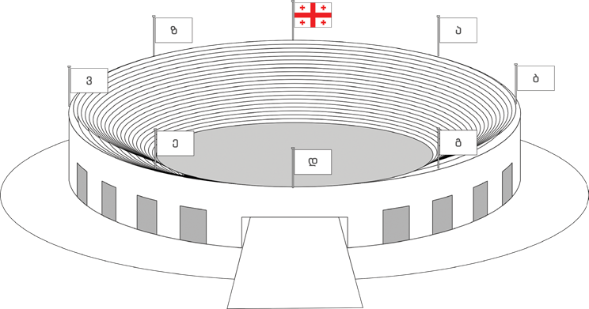
A
G
F
B
E
C
D

Periods of mourning
- In periods of mourning, the state flag of Georgia, together with symbols of state significance (flags), shall be lowered at a height of 1/3 of the flagpole and hoisted at a height of 2/3 of the flagpole.

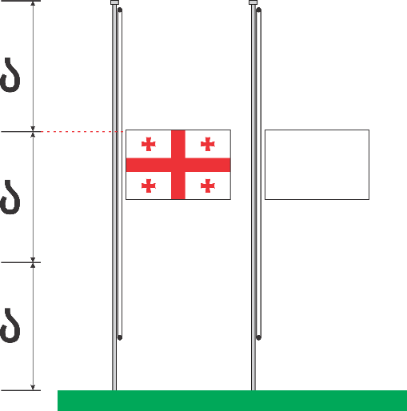
A
A
A

- The procedure for lowering symbols of state significance (flags) together with the state flag of Georgia during periods of mourning shall be that the state flag of Georgia and the symbol of state significance (flag) shall be hoisted to the top of the flagpole and then lowered by 1/3 of the height of the flagpole, to the height of 2/3 of the flagpole.
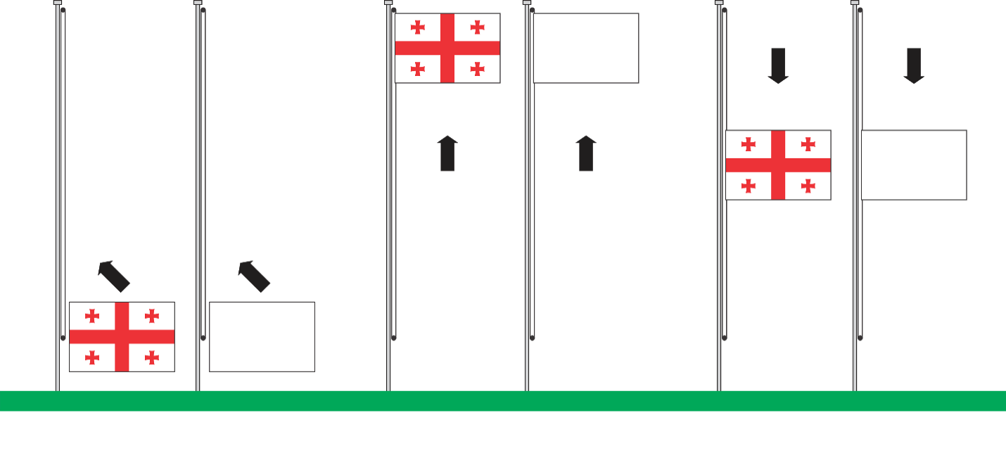
- The procedure for the removal of the state flag of Georgia and state symbols (flags) of Georgia lowered during periods of mourning shall be that the flag lowered by 1/3 of the height of the flagpole and hoisted at the height of 2/3 of the flagpole shall be hoisted first and then lowered and removed.

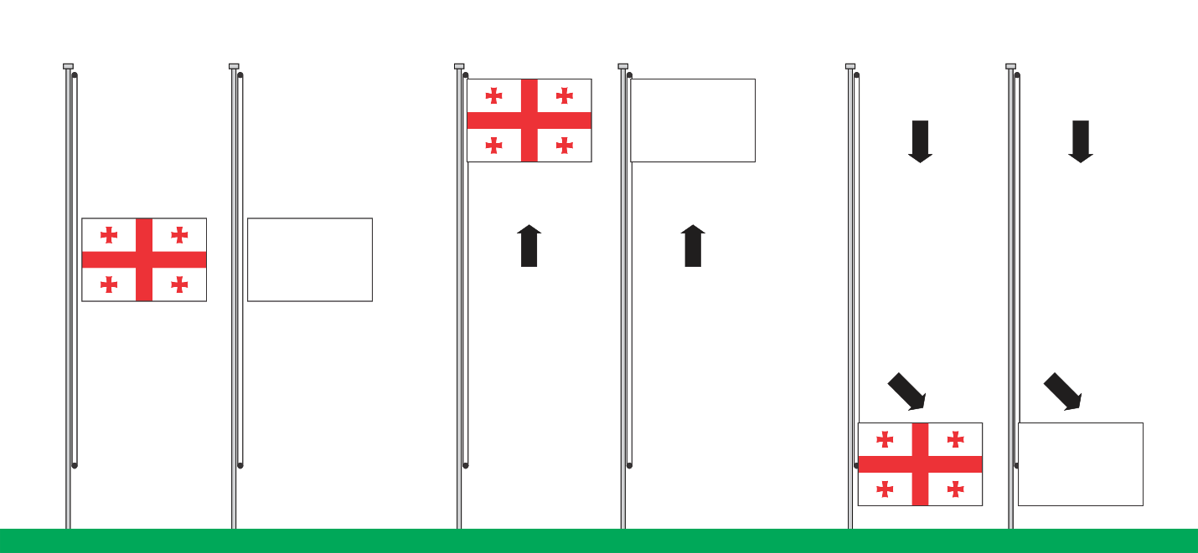

- During periods of mourning, in case of the simultaneous hoisting of the state flag of Georgia and a symbol of state significance (flag), the state flag of Georgia and the symbol of state significance (flag) shall be hoisted with a black ribbon, whose length does not exceed 1/2 of the height of the state flag and the symbol of state significance (flag).
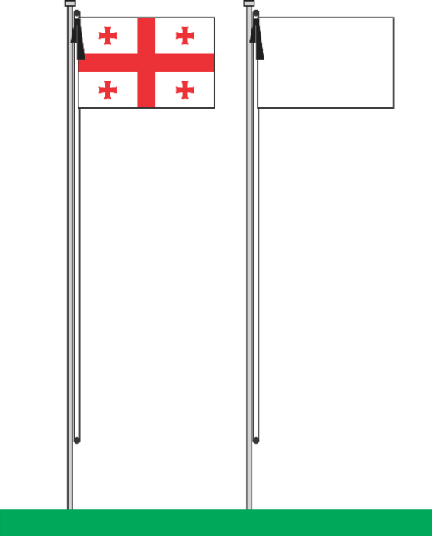

- In the case of displaying flags during periods of mourning, the state flag of Georgia, together with symbols of state significance (flags), shall be displayed with a black ribbon.

Procedure for depicting and displaying symbols of the state significance (coat of arms, emblem) together with the state coat of arms of Georgia

- A public institution, in the absence of a symbol of state significance (coat of arms, emblem) or when displaying only one symbol, shall display a large or small state coat of arms of Georgia in full, in colour, in a single colour, using the procedure for heraldic shading of colour and metal.
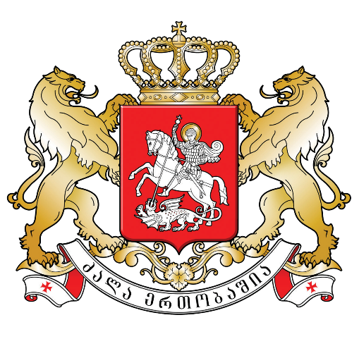
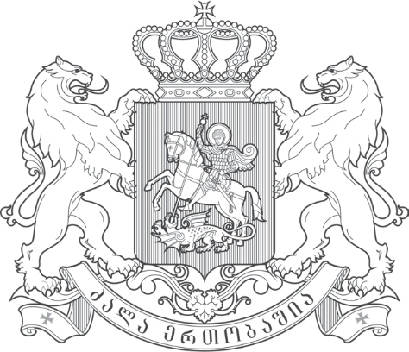

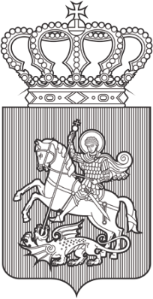
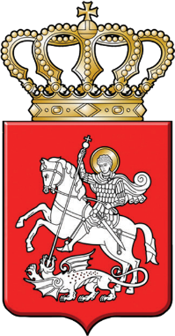

- A symbol of state significance (coat of arms, emblem) shall be displayed in colour, in contour, in a single colour, or using colour and metal.

Displaying a symbol of state significance (coat of arms, emblem) together with the state coat of arms of Georgia according to significance
State coat of arms of Georgia
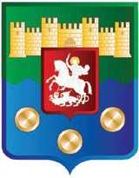
Coat of arms of an Autonomous Republic

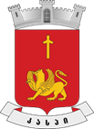
Coat of arms of a municipality

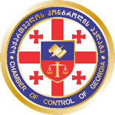
Emblem of a public institution

- The state coat of arms of Georgia shall be given priority and a place of honour in the territory of Georgia in relation to a symbol of state significance (coat of arms, emblem), as well as to all other coats of arms.
- The state coat of arms of Georgia, when together with a symbol of state significance (coat of arms, emblem), shall be displayed at the right edge to the state representative.
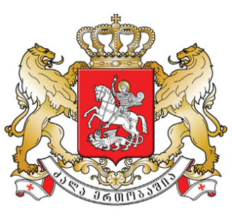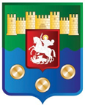

- When displaying three, or other odd number, of coats of arms and symbols of state significance (coat of arms, emblem), the state coat of arms shall be displayed in the middle.

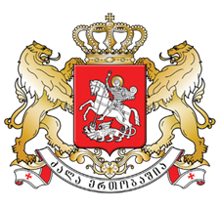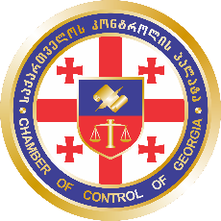

- When displaying four, or other even number, of state coats of arms and symbols of state significance (coat of arms, emblem) together, the state coat of arms of Georgia shall be displayed first from the middle, to the right of the state representative.

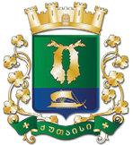

It is inadmissible to:
- display a state symbol of Georgia (coat of arms, emblem) above the state coat of arms of Georgia.
- display a symbol of state significance (coat of arms, emblem) of a larger size than the state coat of arms of Georgia together with the state coat of arms of Georgia.
- display the state coat of arms or a symbol of state significance (coat of arms, emblem) of Georgia in a damaged form.

Other occasions of displaying a symbol of state significance (coat of arms, emblem)

- When a representative of the state (public institution) gives a speech, the state coat of arms of Georgia or the symbol of state significance (coat of arms, emblem) of the institution shall be displayed on the platform.
- When two representatives of state (public institution) give a speech, the state coat of arms or symbols of state significance (coat of arms, emblem) shall be displayed on the platforms of both representatives.
- When a representative of the state (public institution) gives a speech, the state coat of arms shall be displayed on the platform and the symbol of state significance (coat of arms, emblem) shall be displayed behind the representative, above, or vice versa.
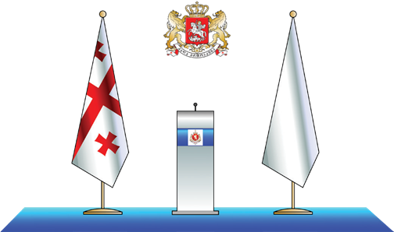

- The state coat of arms of Georgia or a symbol of state significance (coat of arms, flag) shall be displayed in the office of a representative of the state (public institution) behind the representative, above, in the middle.

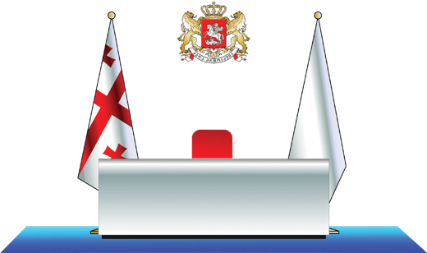

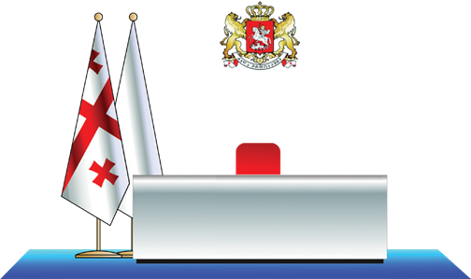

- In the office of a representative of the state (public institution) the symbol of state significance (coat of arms, flag) shall be displayed behind the representative, above, in the middle.

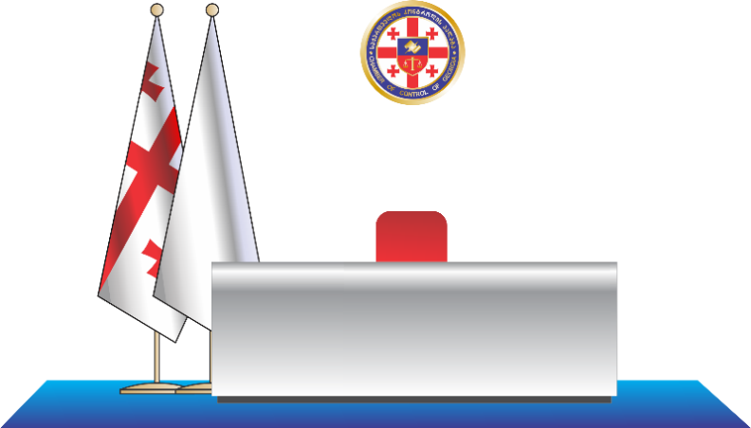

- In the office of a representative of the state (public institution), the state coat of arms of Georgia, together with the symbol of state significance (coat of arms, emblem), shall be displayed behind the state representative, above, at the right edge.



